Task 8 – Evidence Report
Alerting Rules for the DSYS601 Observability Lab
Student | Kabir Singh Thukrai
Student ID | 99281336
Course | BCIS309 – Work Integrated Learning Project
Task | Task 8 – Alertmanager alerting rules (CrashLoopBackOff, container near its memory limit, pod stuck not-ready, node resource pressure)
Rules | 4 rules in monitoring/alerts/dsys601-alerts.yaml
Repository | https://github.com/kat0870/dsys601-k8s-observability-lab
Date | 28 September 2026

1. What this task was about
The brief asks for alert rules for four failure conditions: CrashLoopBackOff, a container near its memory limit, a pod stuck not-ready, and node resource pressure. They should catch real problems but not fire on normal ups and downs. I also wanted them stored in the repo and loaded automatically, like the dashboard in Task 7.

2. How Prometheus finds rules
Prometheus only loads PrometheusRule objects that match its ruleSelector. I checked it and the label is release: kube-prometheus-stack, so my rule file uses that label (Figure 1).
The chart already has built-in rules like KubePodCrashLooping and KubePodNotReady, but they watch the whole cluster and wait about 15 minutes. I kept them and wrote my own rules with a DSYS601 prefix, limited to the demo-app namespace.
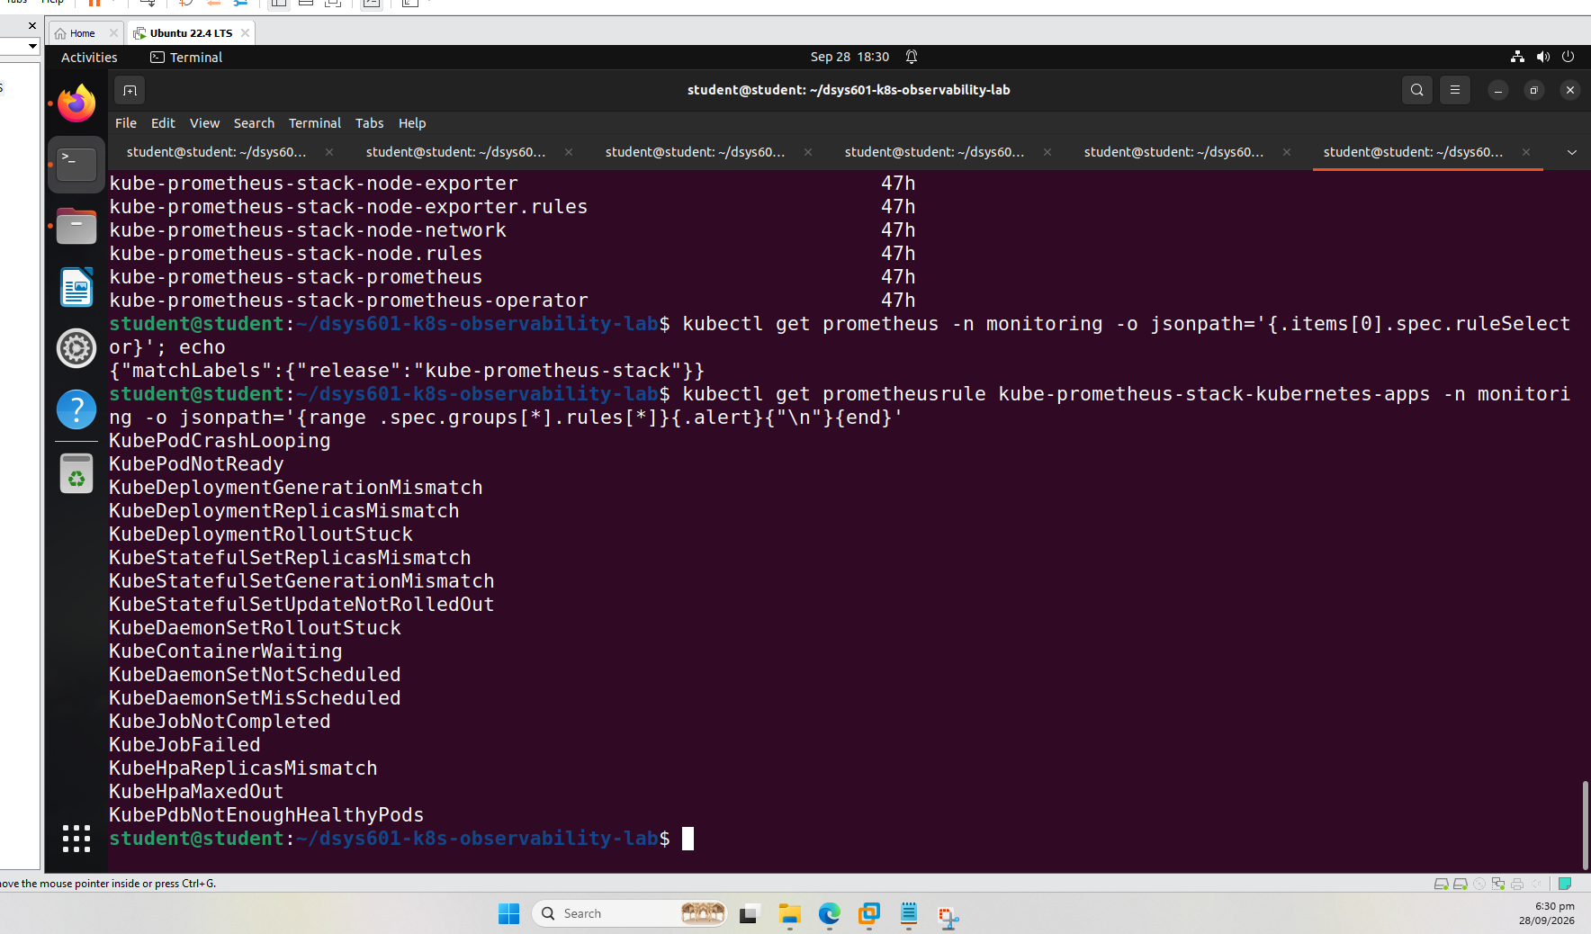
Figure 1. The ruleSelector label and the built-in pod alerts

3. The four rules
Alert | Fires when | Wait | Severity
DSYS601PodCrashLooping | A container was in CrashLoopBackOff in the last 5 minutes | 5m | critical
DSYS601ContainerMemoryNearLimit | A container uses more than 90% of its memory limit | 10m | warning
DSYS601PodNotReady | A pod that should be running is not Ready | 5m | warning
DSYS601NodeUnderPressure | A node reports memory, disk or PID pressure | 10m | warning

The wait time means the problem has to last before the alert fires, so short spikes, pod startups and rollouts do not trigger it.
CrashLoopBackOff
max_over_time(kube_pod_container_status_waiting_reason{namespace="demo-app", reason="CrashLoopBackOff"}[5m]) >= 1
A crashing container keeps switching between CrashLoopBackOff and Running, which would keep resetting the timer. max_over_time over 5 minutes fixes that. The rule loaded and showed as Inactive, since nothing was crashing (Figure 2).
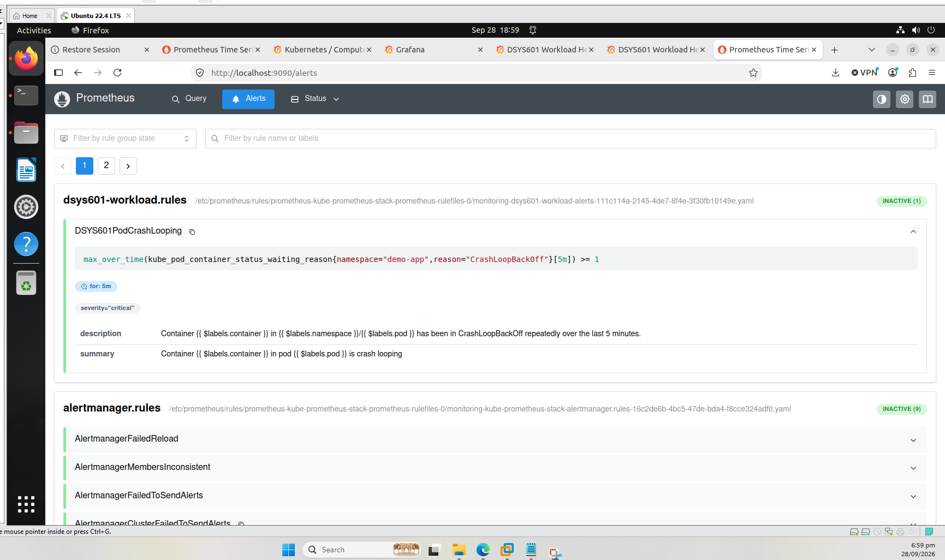
Figure 2. CrashLoop rule loaded and inactive
One thing I noticed: a new rule takes about a minute to show up in Prometheus, so I need to wait before testing in Task 9.
Memory near limit
This divides each container's working-set memory by its memory limit. On the healthy app all five containers were under 4% (Figure 3), so a 90% limit for 10 minutes will only catch a real problem.
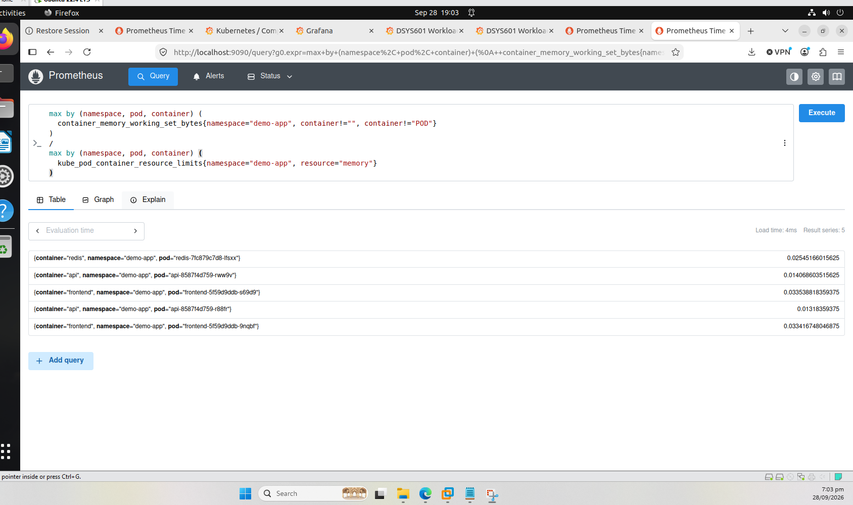
Figure 3. Memory use as a share of the limit, all under 4%
Pod not-ready
This finds pods that are not Ready but should be running (Pending, Running or Unknown), so finished pods are ignored. On the healthy app the query returned no data (Figure 4).
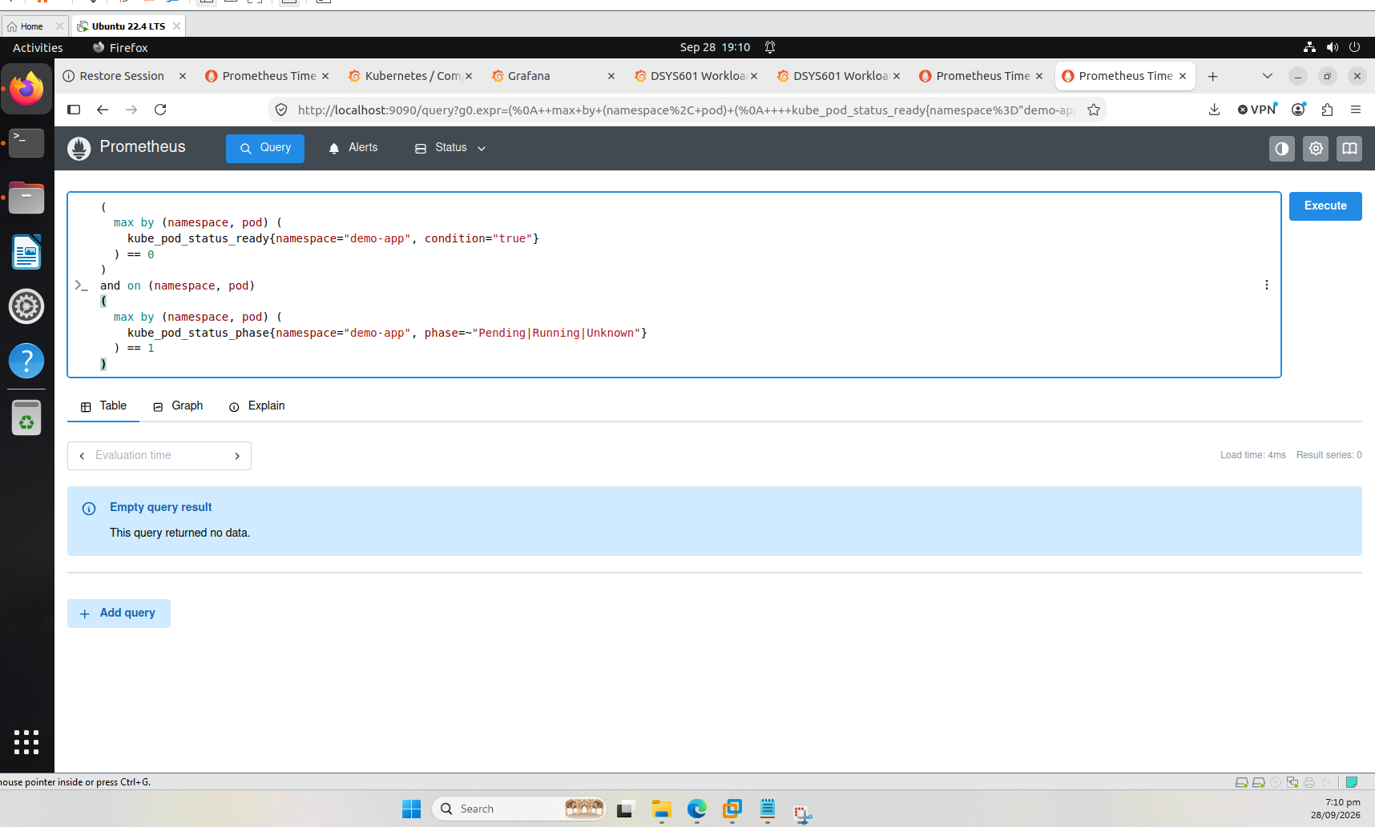
Figure 4. Not-ready query returns no data on the healthy app
Node pressure
My three nodes are Docker containers on one VM, so node-exporter reports the same memory for all of them (Figure 5). Alerting on that would give three alerts for one problem.
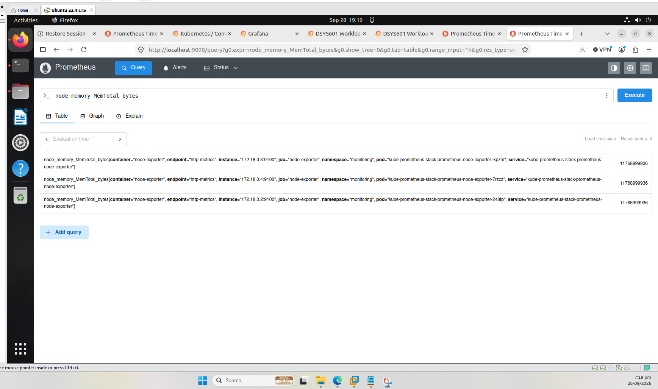
Figure 5. All three node-exporters report the same total memory
So I used the kubelet's own pressure conditions from kube_node_status_condition instead. All nine were 0 on the healthy cluster (Figure 6). The kubelet keeps a pressure condition on for about 5 minutes after it clears, so I used a 10 minute wait.
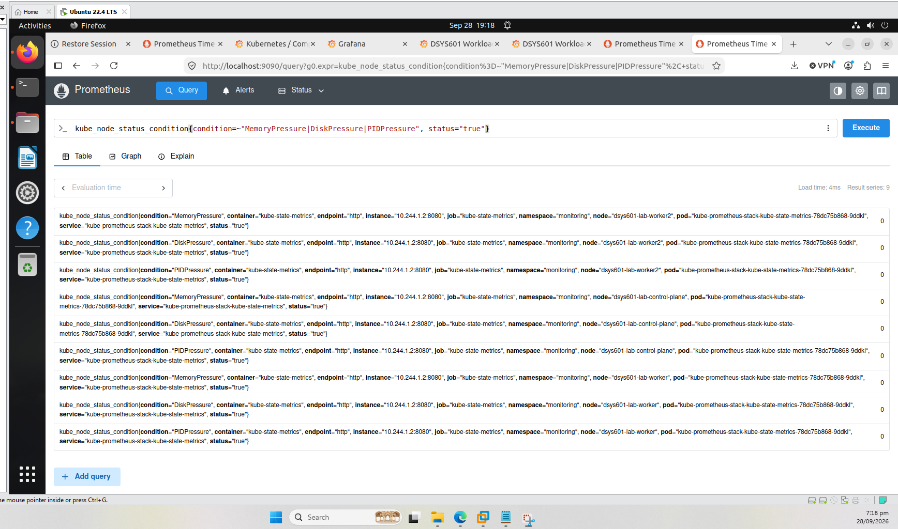
Figure 6. Pressure conditions for each node, all 0
All four rules loaded and were inactive (Figure 7).
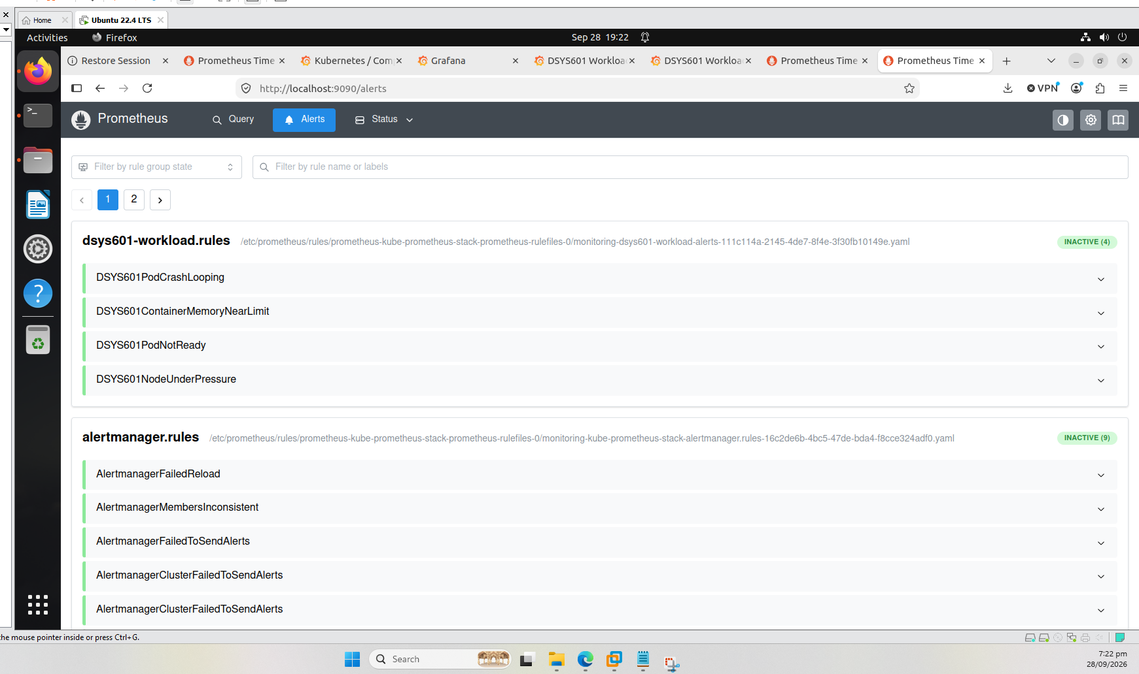
Figure 7. All four DSYS601 rules loaded: INACTIVE (4)

4. Loading the rules automatically
I added one line to the end of setup-monitoring.sh, after helm install (Figure 8):
kubectl apply -f "$SCRIPT_DIR/alerts/"
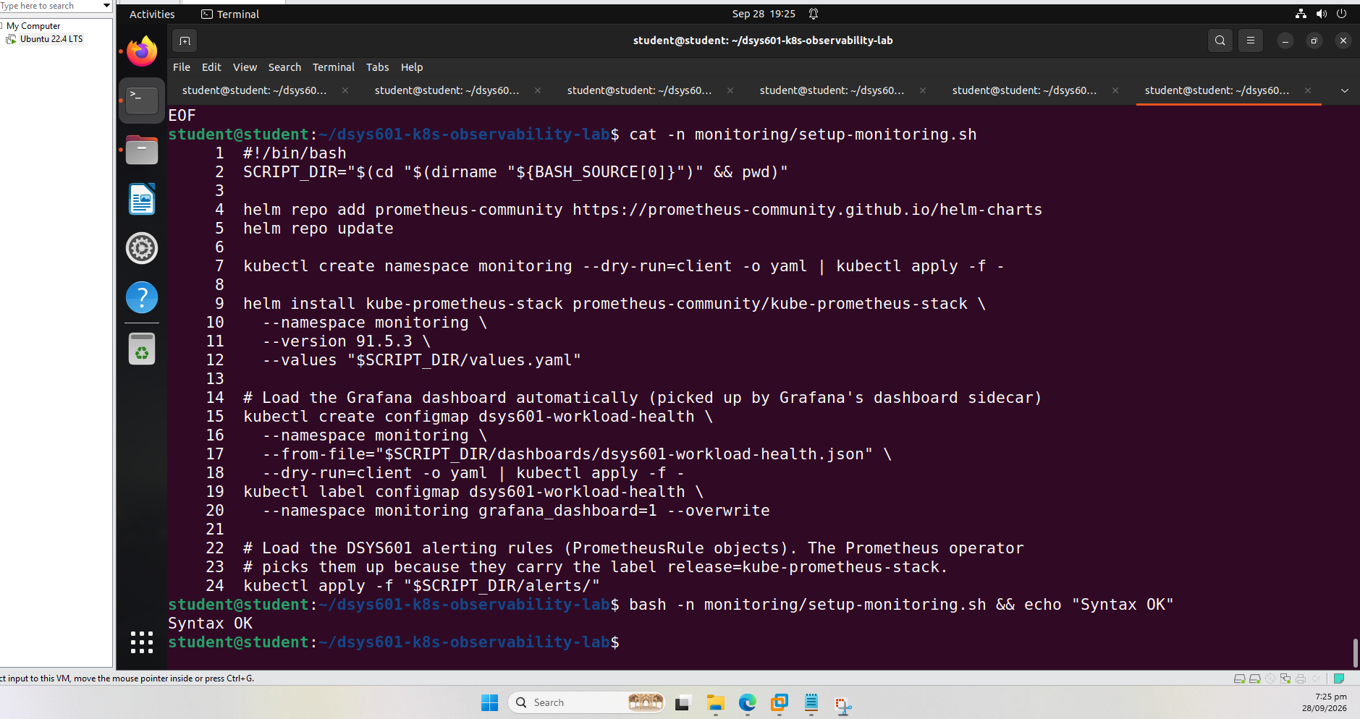
Figure 8. New line at the end of setup-monitoring.sh
To test it I deleted the cluster and rebuilt it using only the repo scripts:
./cluster/teardown-cluster.sh
./cluster/setup-cluster.sh
kubectl apply -f app/demo-app.yaml
./monitoring/setup-monitoring.sh
The new nodes were only seconds old (Figure 9), and the setup script created the rules (Figure 10).
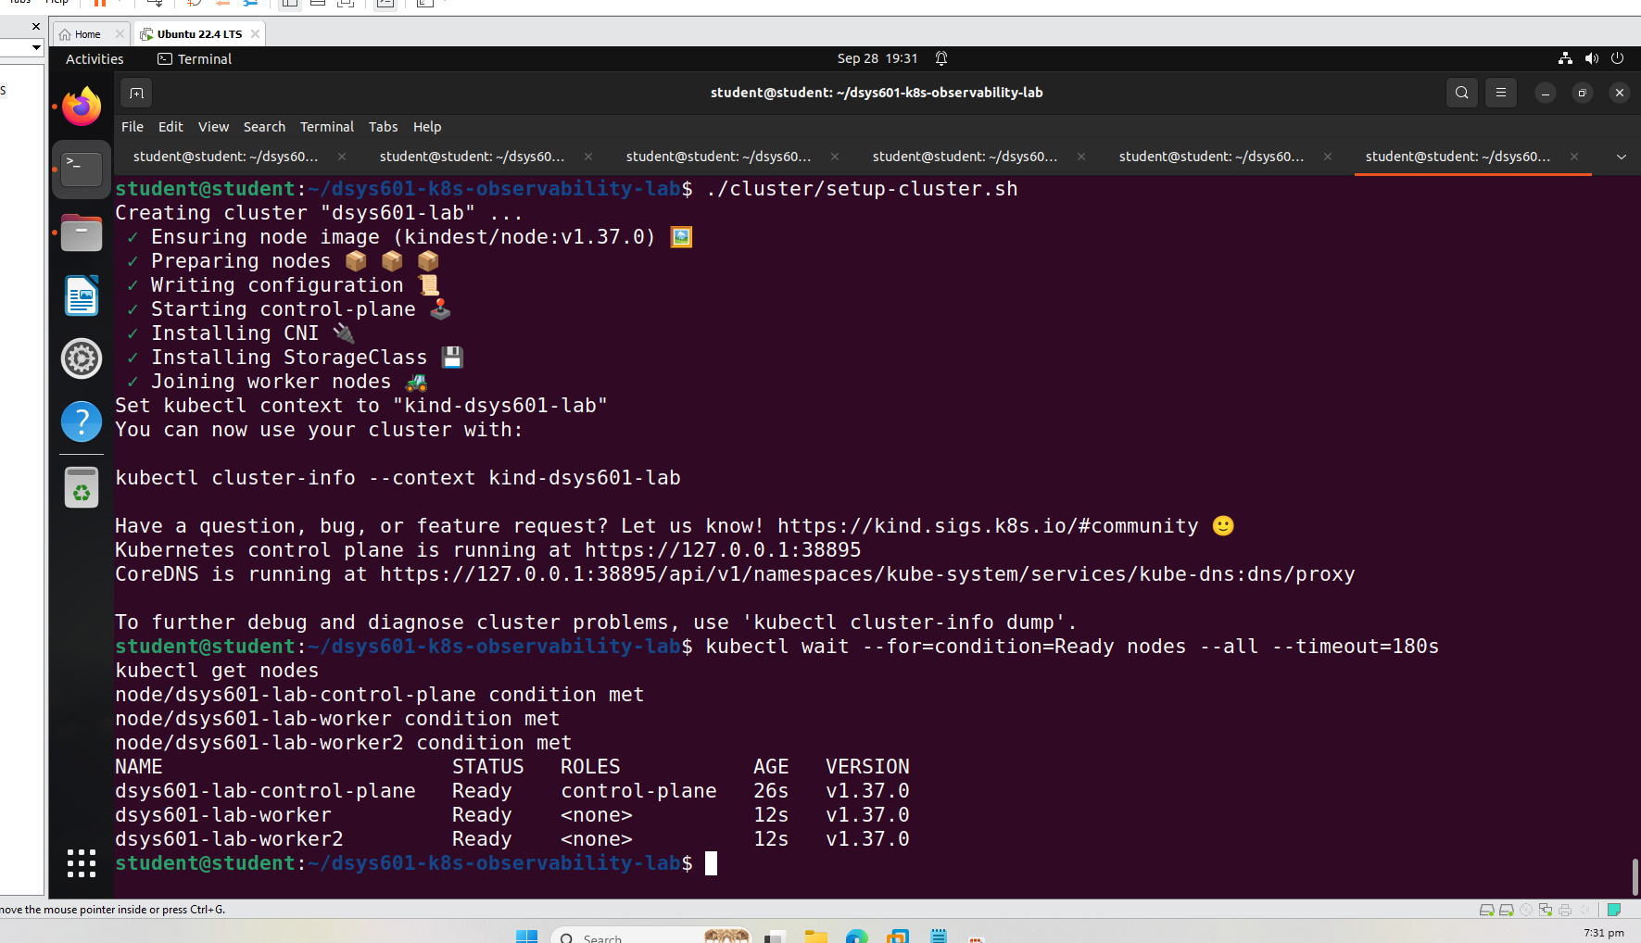
Figure 9. Fresh cluster after the rebuild
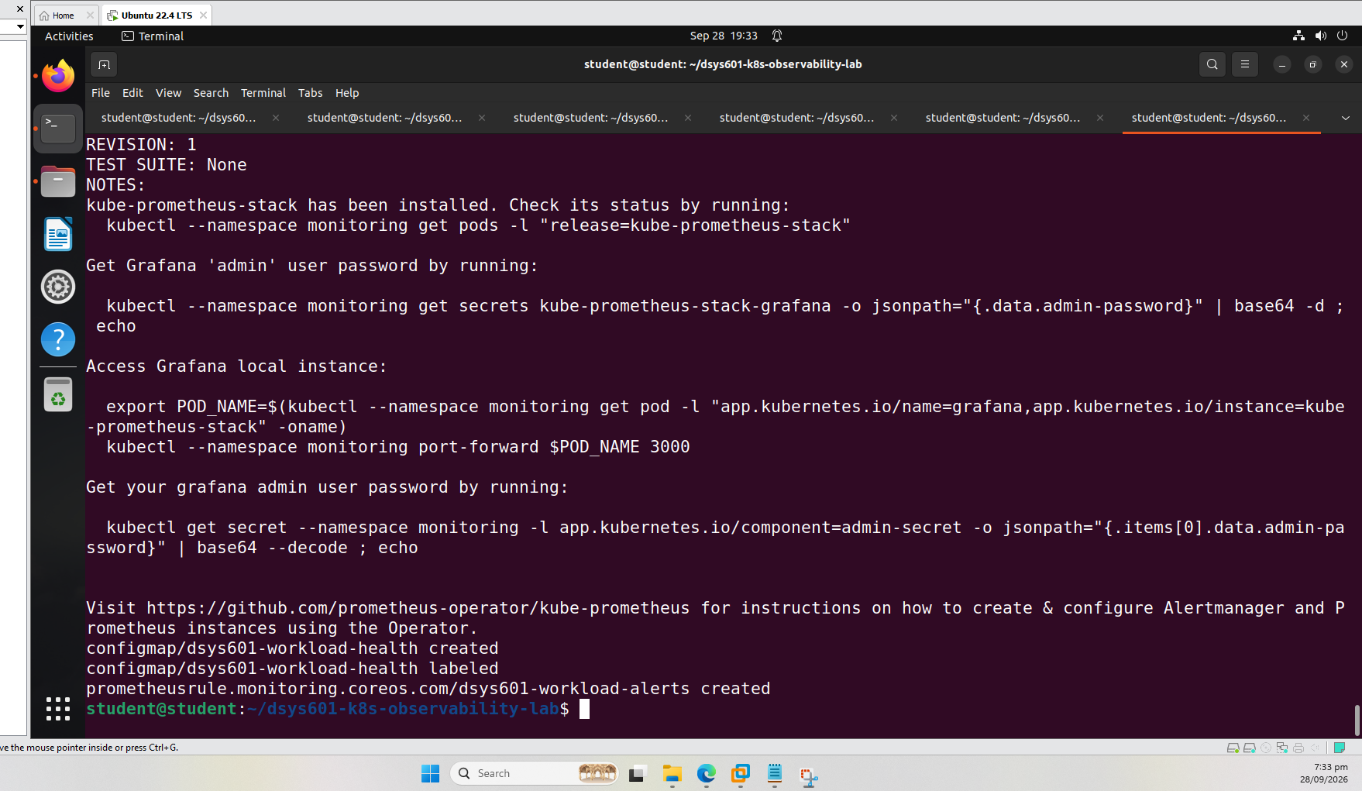
Figure 10. setup-monitoring.sh creating the alert rules
All four rules loaded again without me applying anything by hand (Figure 11).
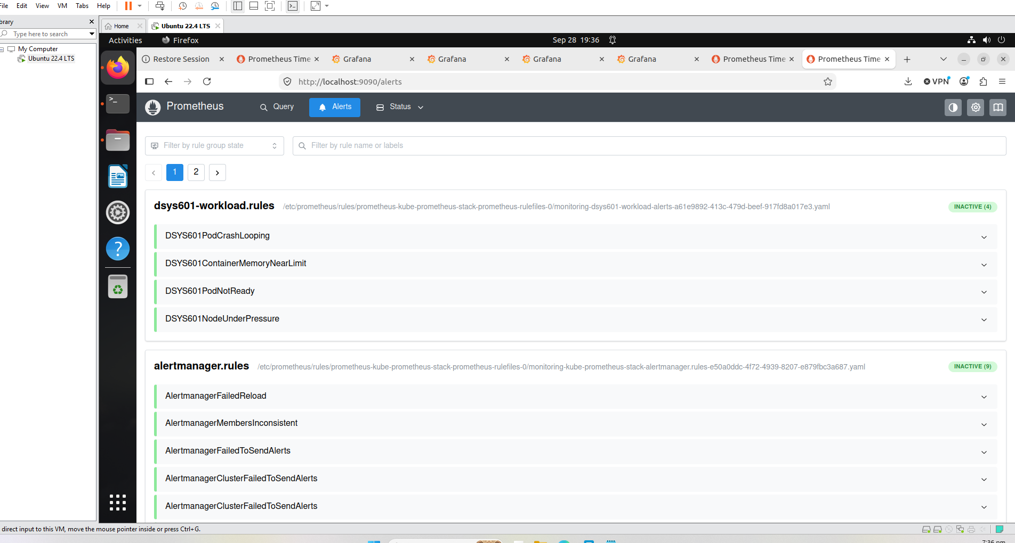
Figure 11. Alerts page after the rebuild
I also added a monitoring and alerting section to the README, which was missing before.

5. Where this leaves Task 8
Brief requirement | Covered by
CrashLoopBackOff | DSYS601PodCrashLooping
Container near its memory limit | DSYS601ContainerMemoryNearLimit
Pod stuck not-ready | DSYS601PodNotReady
Node resource pressure | DSYS601NodeUnderPressure
No alerts on normal fluctuation | 5 to 10 minute waits; all inactive on the healthy app
Stored in the repo, loaded automatically | setup-monitoring.sh, tested with a full rebuild

The work is in six commits (Figure 12).
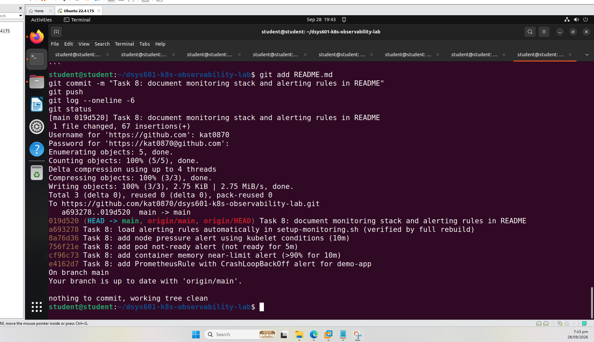
Figure 12. Task 8 commits pushed to GitHub
So far the rules have only been shown staying quiet on a healthy app. In Task 9 I will break the demo app to make them fire. For node pressure I will use promtool test rules, because causing real pressure could freeze the VM.
Repository: https://github.com/kat0870/dsys601-k8s-observability-lab

